How to run the app

1. Clone the repository:

Open a terminal and clone the repository

git clone https://github.com/MartinSimeonov99/Minimal-API-with-FastAPI.git

1. Change to the project directory:

cd YOUR_REPOSITORY

1. Install the dependencies:

pip install -r requirements.txt

1. Start the server:

uvicorn main:app --reload

1. Terminal (as in the requirements)

1. Open a terminal window and navigate to the directory where your **main.py** file is located.
2. Run the following command to start the FastAPI application: **uvicorn main:app --reload**
3. Open a new terminal window and navigate to the same directory.
4. To test the **GET** method, run the following command: **curl http://localhost:8000/address/ latitude=42.62521770636195&longitude=23.355158601013592&radius=5.** Note that you should replace the latitude and longitude values with your own coordinates. Make sure to replace **localhost** with the appropriate IP address or hostname if you're accessing the API from a different machine.
5. To test the **POST** method, run the following command: **curl -X POST "http://localhost:8000/address" -H "accept: application/json" -H "Content-Type: application/json" -d "{\"address\": \"Sofia, Bulgaria\",\"latitude\": 42.62521770636195,\"longitude\": 23.355158601013592}"**. Note that you should replace the latitude and longitude values with your own coordinates.
6. To test the **PUT** method, run the following command: **curl -X PUT "http://localhost:8000/address/1" -H "accept: application/json" -H "Content-Type: application/json" -d "{\"address\": \"Updated Address\",\"latitude\": 42.62521770636195,\"longitude\": 23.355158601013592}"**. Note that you should replace the address, latitude and longitude values with your own.
7. To test the **DELETE** method, run the following command: **curl -X DELETE "http://localhost:8000/address/1" -H "accept: application/json"**. Note that you should replace the ID value with the ID of an address that exists in your database.

2. Swagger UI

1. Assuming that you have already started the server (else refer to first 2 steps in example 1), open a web browser and go to <http://localhost:8000/docs>. . Make sure to replace **localhost** with the appropriate IP address or hostname if you're accessing the API from a different machine.
2. You can test each endpoint by clicking on it, filling out the required parameters, and clicking "Execute".You can also see the request and response bodies and headers by clicking on the "Example Value" section.

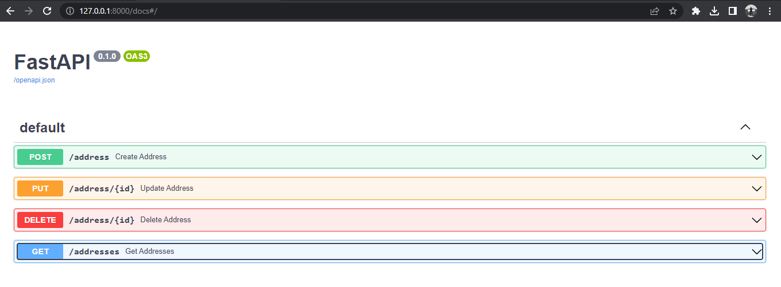

1. Using the provided files
2. Open the repository/folder, from the FastAPI folder you can access the provided .py files

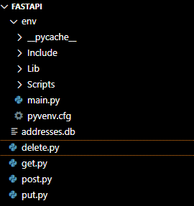

1. You can test each Method in the file with a name corresponding to the specific method.
2. Instructions can be found as a #comments in the beginning of each file. You just to follow them and execute the file after.

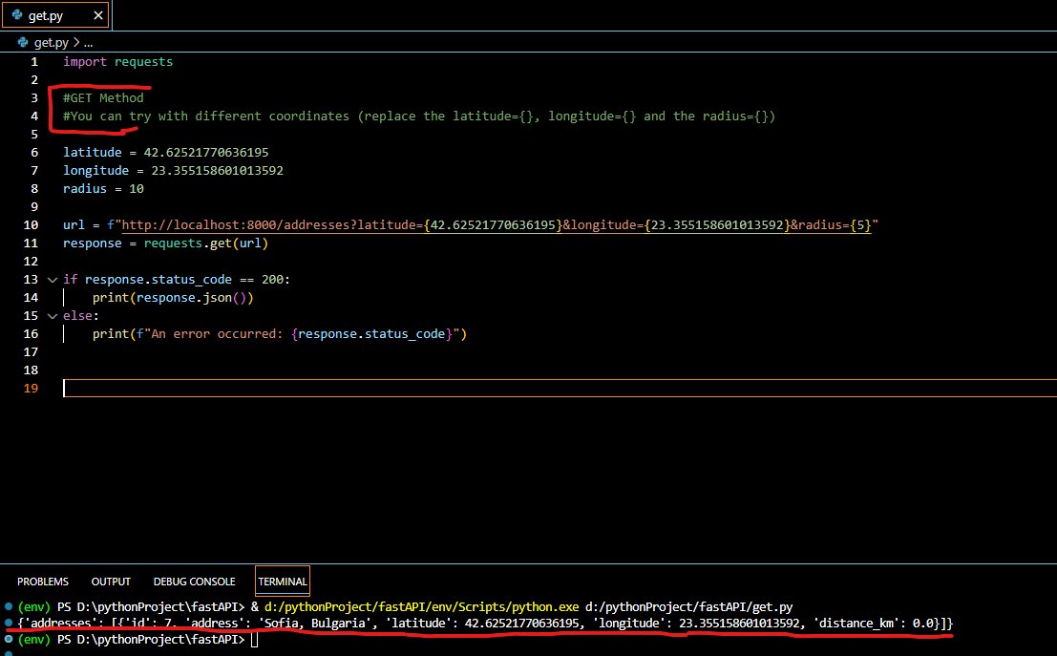

1. And the results will be shown in the console as a output.